Contents
Statin Efficacy Comparison 1
Properties of Statins 2

Statin Efficacy Comparison
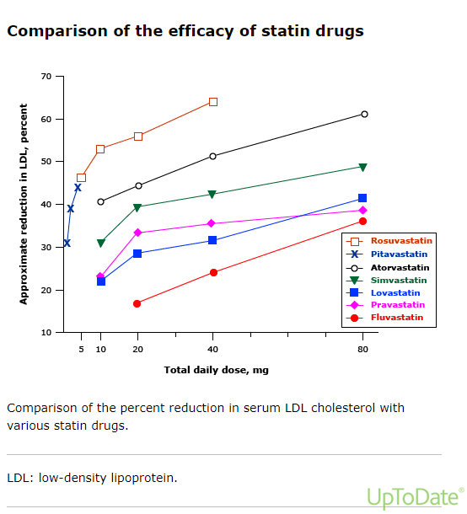

Properties of Statins
